**Instruction sheet**

1) The next phase is almost exactly the same as the last. The only difference is that the items coming up on screen will all be new, and won’t be repeated.

2) The same category that was rewarded before will be rewarded again this time.

**REMEMBER: The money you win on the task will affect how much you take home at the end of session two.**

3) Don’t forget that you **MUST** respond, whether there is reward available or not. However if there is reward available, you must respond especially quickly to receive it. You will no longer be told if you were too slow, so the possible outcomes are:

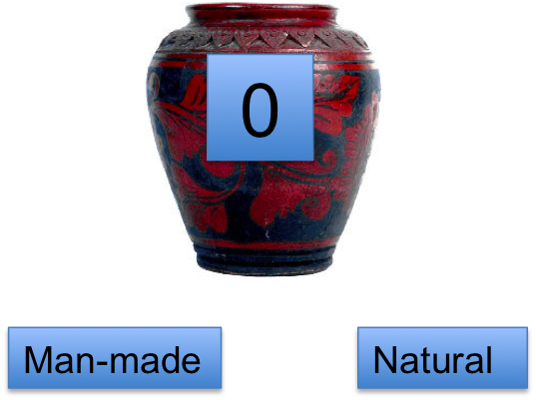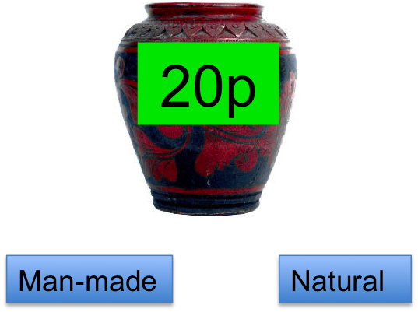

**OR**

Like before, a picture of a room will also be shown onscreen, before the items are presented. These pictures are not relevant to the task at all – they have no relationship to what type of items are likely to come out, or whether you are likely to win money or not. The task that you are doing only relates to the pictures of the natural and man-made items that come onscreen.

Please respond accurately to every single item, whether or not there is money available for you to win. **If your accuracy in this task falls too low, you will not receive the money that you have made on the task.**